Year 10 · Cambridge IGCSE

NAME

CLASS |  |  | DATE

COMPUTER SCIENCE 0478
Papers 1 and 2
Revision Paper about 2 hours 15 minutes
Answer on the question paper.

INSTRUCTIONS
- Answer all questions.
- Show all your working for conversions and binary calculations.
- Use a pencil for diagrams, flowcharts and lines.
- Calculators must not be used.

INFORMATION
- The total mark is 114.
- The number of marks for each question or part question is shown in brackets [ ].
- Section A: Chapter 1 Data representation and Chapter 2 Data transmission (Questions 1–8).
- Section B: Chapter 7 Algorithm design and problem-solving (Questions 9–15).

For teacher use
Question | 1 | 2 | 3 | 4 | 5 | 6 | 7 | 8 | A
Marks | 11 | 10 | 10 | 6 | 10 | 4 | 6 | 12 | 69
Score

Question | 9 | 10 | 11 | 12 | 13 | 14 | 15 | B | Total
Marks | 4 | 3 | 4 | 10 | 8 | 10 | 6 | 45 | 114
Score

This document has 16 pages.
Section A
Chapter 1 Data representation · Chapter 2 Data transmission
1 Binary is a number system used by computers.
(a) Tick (✓) one box to show which statement about the binary number system is correct.
A | It is a base 1 system
B | It is a base 2 system
C | It is a base 10 system
D | It is a base 16 system

[1]
(b) Denary numbers are converted to binary numbers to be processed by a computer.
Convert these three denary numbers to 8-bit binary numbers.
50
102
221 [3]
Working space

(c) Binary numbers are stored in registers. Negative denary numbers can be represented as binary using two’s complement.
Complete the binary register for the denary number –78. You must show all your working.
Working space

Register: [2]

(d) Two 8-bit binary numbers are given. Add the two 8-bit binary numbers using binary addition. Give your answer in binary. Show all your working.
+ | 0  0 | 0  1 | 1  1 | 1  0 | 0  0 | 0  0 | 1  0 | 1  1

[3]
(e) Two binary numbers are added by a computer and an overflow error occurs. Explain why the overflow error occurred.

[2]
2 Binary numbers can be converted to hexadecimal.
(a) Convert the two binary numbers to hexadecimal.
10010011
00001101 [4]
Working space

(b) A value is stored as a binary number in a register.
0 | 1 | 1 | 1 | 1 | 0 | 1 | 0

A logical right shift of three places is performed on the binary number.
(i) Complete the binary register to show its contents after this logical right shift.

[1]
(ii) State one effect this logical shift has on the binary number.
[1]
(c) Give two reasons why a programmer may use hexadecimal to represent binary numbers.
1
2 [2]
(d) Denary numbers can also be converted to hexadecimal. Convert the denary number to hexadecimal.
301 [2]
Working space

3 When keys are pressed on a keyboard, the text is converted to binary to be processed by the computer.
(a) Describe how the text is converted to binary to be processed by the computer.

[3]
(b) Text that is input into a computer can be stored in a text file. A text file can be compressed using lossless compression.
(i) State what effect this has on the file size.
[1]
(ii) Describe how lossless compression compresses the text file.

[4]
(iii) Give two reasons why the text file may have been compressed.
1
2 [2]
4 A photographer takes an image with a digital camera. The photographer sets the resolution and colour depth for the image.
(a) State what is meant by the image resolution.

[1]
(b) State what is meant by the image colour depth.

[1]
(c) Give one benefit of increasing the colour depth of the image.

[1]
(d) The photographer compresses the image using a method that permanently reduces the colour depth and resolution of the image. Identify which compression method the photographer uses.
[1]
(e) One benefit for compressing the image is to reduce the storage space it uses. Give two other benefits of compressing the image.
1
2 [2]
5 A student has a sound file that is too large to be stored on their external secondary storage device. The student compresses the sound file to make the file size smaller. The compression method used reduces the sample rate and the sample resolution of the sound file.
(a) State what is meant by the sample rate and sample resolution.
Sample rate

Sample resolution
[2]
(b) Identify which type of compression has been used to compress the sound file.
[1]
(c) The student sends the sound file to a friend. The file is transmitted across a network that uses packet switching.
(i) Identify two pieces of data that would be included in the header of each packet.
1
2 [2]
(ii) Explain how the file is transmitted using packet switching.

[5]
6 The table contains descriptions about data transmission methods.
Complete the table by identifying which data transmission methods are described.
Data transmission method | Description
 | Data is transmitted down a single wire, one bit at a time, in one direction only.
 | Data is transmitted down multiple wires, multiple bits at a time, in both directions, but only one direction at a time.
 | Data is transmitted down a single wire, one bit at a time, in both directions at the same time.
 | Data is transmitted down multiple wires, multiple bits at a time, in one direction only.

[4]

7 Data is split into packets before it is transmitted across a network.
A packet has three sections. Complete the table by writing the name of each section of the packet and an example of what would be stored in that section.
Section | Name of section | Example of what is stored
First
Second
Third

[6]
8 A barcode scanning system uses a check digit to check for errors in data on input.
(a) Explain how the barcode scanning system operates to check for errors.

[4]
(b) After a barcode is scanned, data is sent to a stock control system to update the stock value stored for that product. The data is sent to the stock control system using serial simplex data transmission.
(i) Explain how the data is sent using serial simplex data transmission.

[3]
(ii) Explain why serial simplex is the most appropriate method of data transmission for this purpose.

[3]
(iii) The data is checked for errors after it has been transmitted to the stock control system. Give two error detection methods that could be used for this purpose.
1
2 [2]
Section B
Chapter 7 Algorithm design and problem-solving
9 Four development life cycle stages and five descriptions are shown.
Draw one line from each stage to the most appropriate description. Not all descriptions will be used.
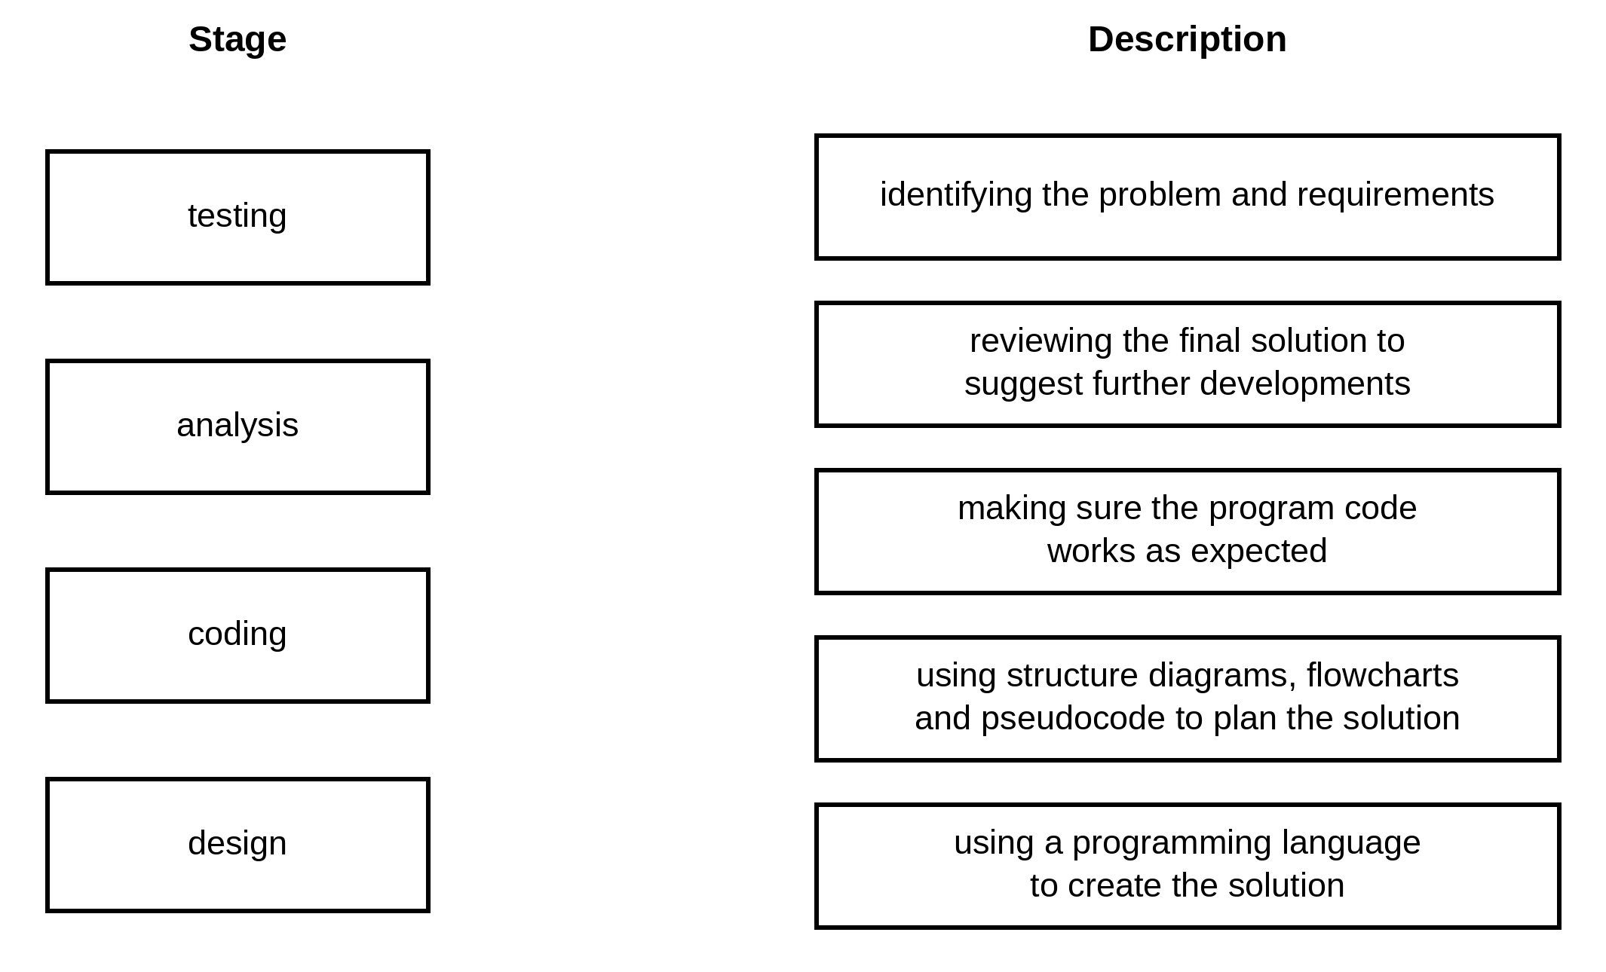
[4]
10 Identify three different ways that the design of a solution to a problem can be presented.
1
2
3 [3]
11 A food ordering system is an example of a computer system that is made up of sub-systems.
The food ordering system:
• allows the user to enter the details of the food they want to order and to pay for the order
• displays food available as pictures or as a list.
Complete the structure diagram for the given parts of the food ordering system.
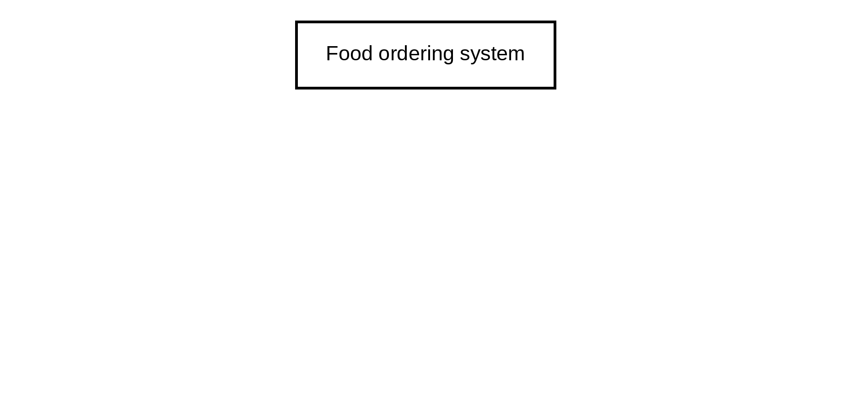
[4]
12 Four flowchart symbols and five purposes are shown.
(a) Draw one line to link each flowchart symbol to its correct purpose. Not all purposes will be used.
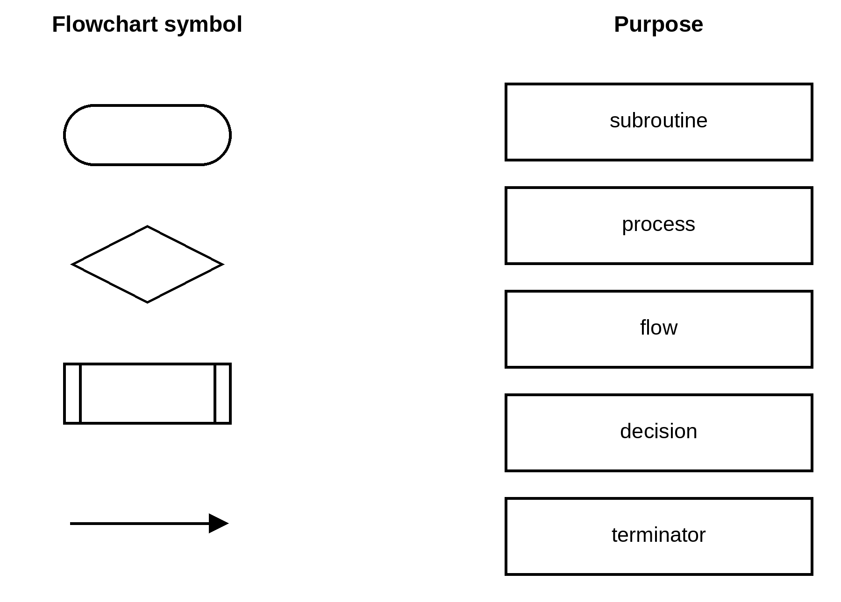
[4]
(b) An algorithm needs to total 50 numbers between 1 and 100 inclusive. Draw a flowchart that:
• uses a count-controlled loop from 1 to 50
• uses an appropriate prompt to ask for a number between 1 and 100
• totals the numbers as they are entered
• outputs the total after the loop has completed with an appropriate message. [6]
13 Tickets for a theme park are booked online. An adult ticket costs $12.99 and a child ticket costs $7.99. A booking fee of $1.99 is added to the total cost of each booking.
(a) Write an algorithm in pseudocode to:
• input the number of adult tickets for a booking
• input the number of child tickets for a booking
• calculate and output the total cost of the booking using an appropriate message.

[4]
(b) Each booking must have at least one adult ticket. Explain how the algorithm could be changed to repeatedly ask for the number of adult tickets if the number input is less than 1. Any code used must be fully explained.

[4]
14 The flowchart represents an algorithm.
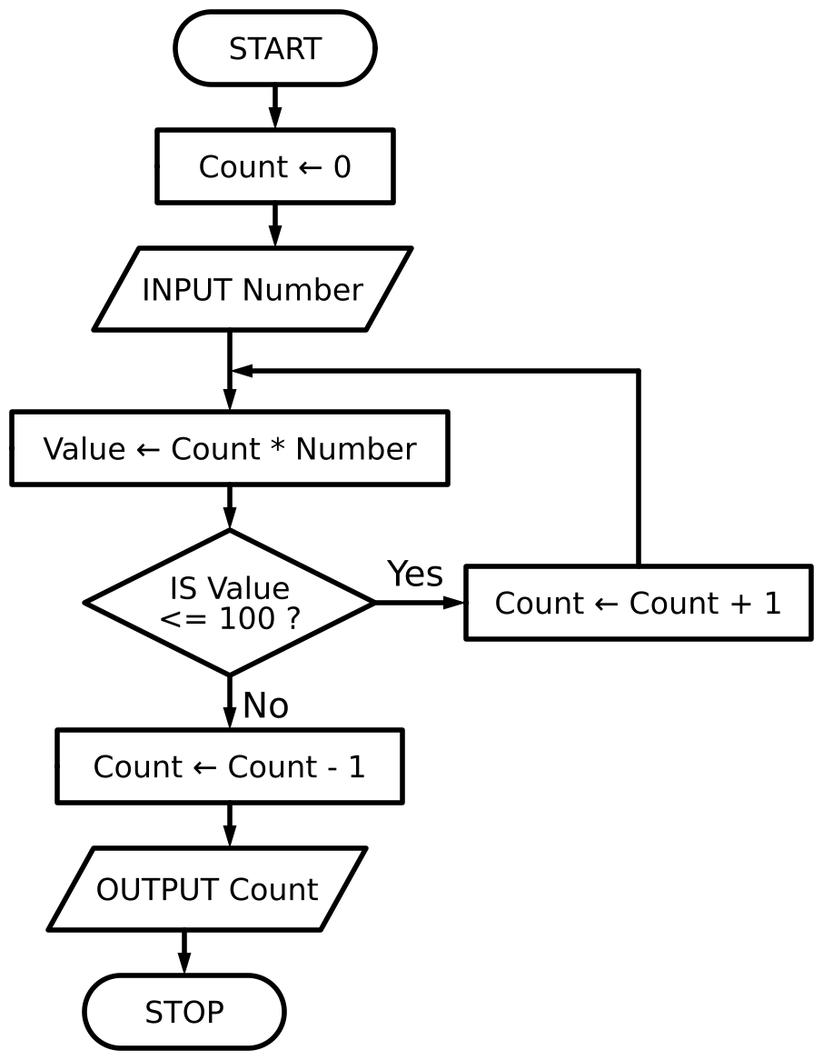
(a) Complete the tables, using the flowchart, for the given data:
Input data: 20
Count | Number | Value | Output

Input data: 110 [4]
Count | Number | Value | Output

(b) State the purpose of the algorithm.

[1]
(c) State a suitable data type for the variable Count.
[1]
(d) Write the algorithm in pseudocode.

[4]

15 The flowchart represents an algorithm. It uses the one-dimensional (1D) array ClassList.
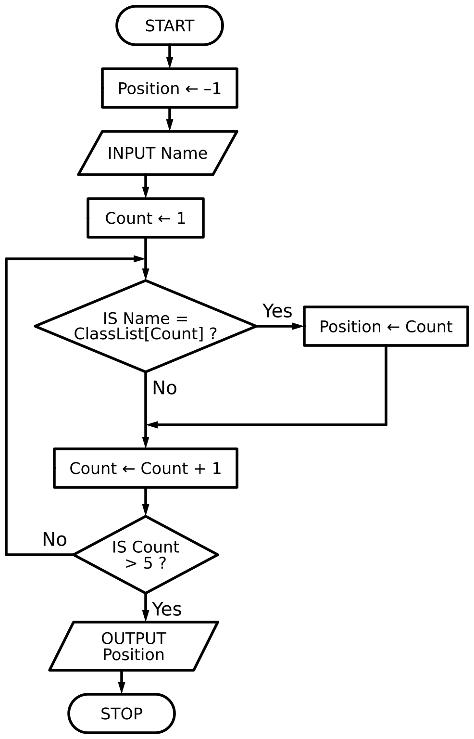
(a) ClassList contains the following data:
Index | 1 | 2 | 3 | 4 | 5
ClassList | Henil | Sven | Ella | Asia | Ridwan

Complete the table by writing the output from the flowchart when each of the given names is input.
Name | OUTPUT
Ridwan
Yan
Ella

[2]
(b) Identify the standard method of solution used by the flowchart.
[1]
(c) Write pseudocode to declare the array ClassList and to store the five names shown in part (a).

[3]

END OF PAPER

